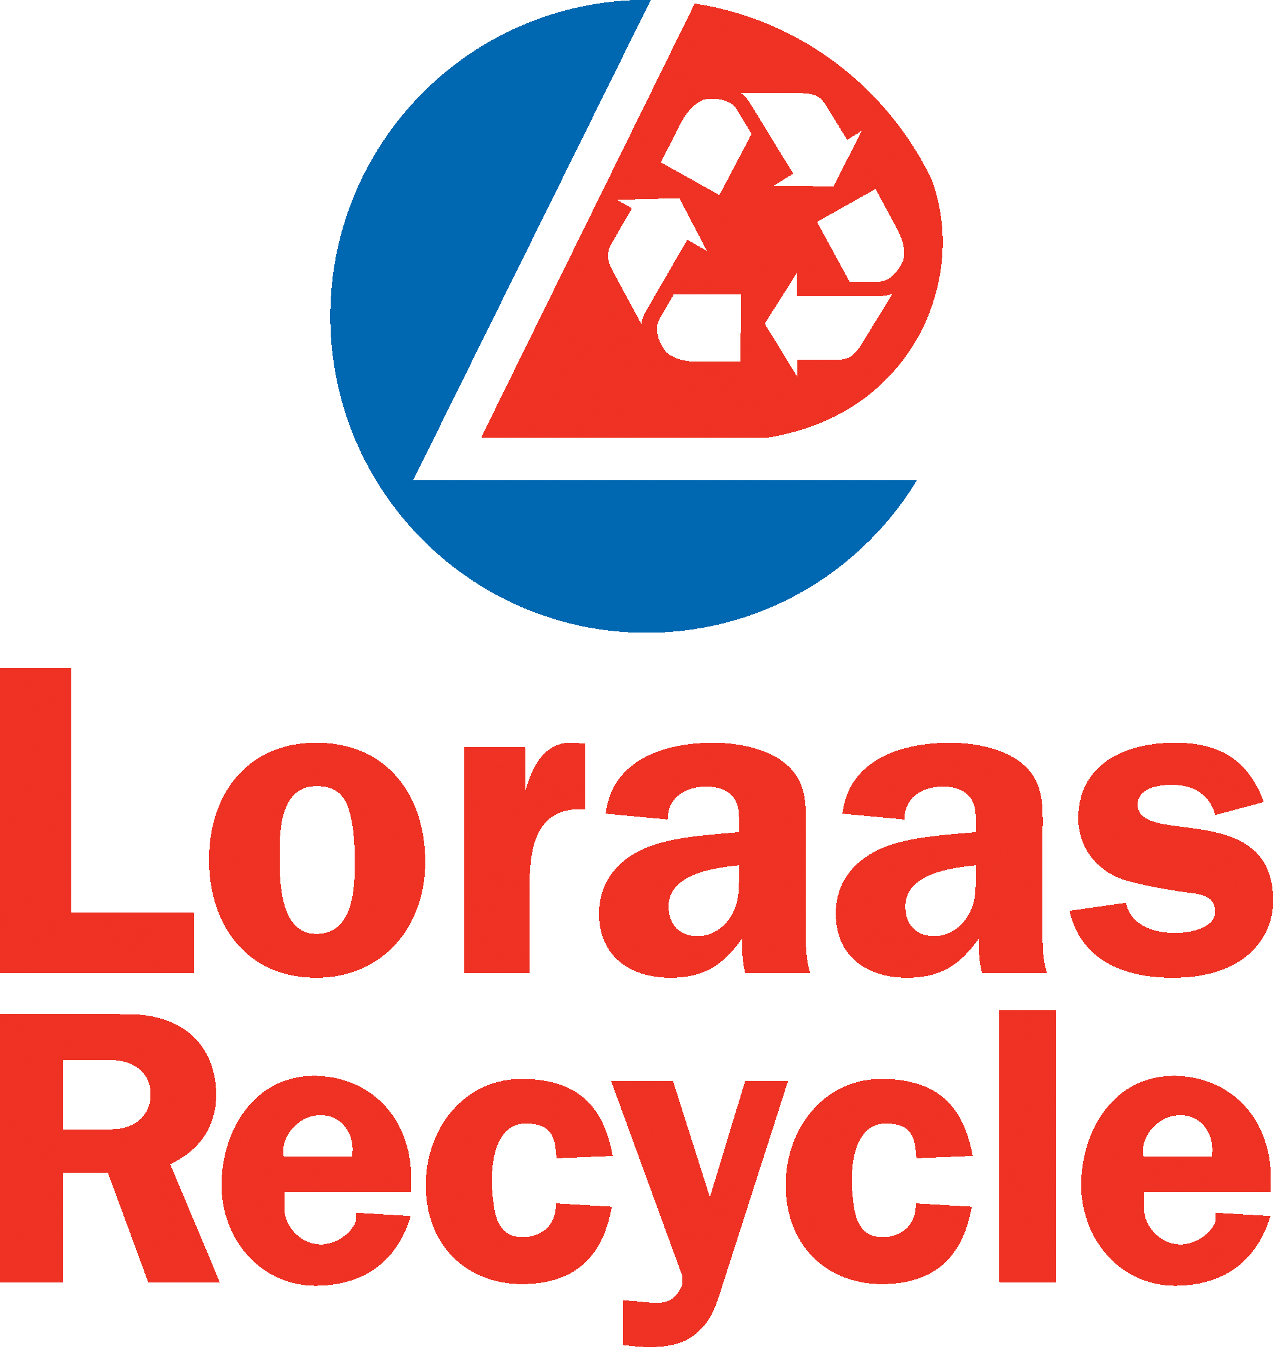

General Guidelines for Single Stream Recycling

Welcome to single stream recycling! With a single stream program, all approved materials can be placed together in your blue recycle bin without being separated. Please follow these general guidelines for approved recyclable material. Thank you for choosing Loraas Recycle. Happy recycling!

Beverage containers:
- Aluminum pop and beer cans
- Plastic pop/water bottles, plastic milk jugs
- Milk cartons, juice boxes, and all Tetra-pak containers
- Wine, spirit, and beer bottles
- Jars/bottles (pickle, jam, ketchup, etc.)
- Not accepted: glass cups or dishware, ceramics, ashtrays, window glass, mirrors, light bulbs or crystal

Metal (please rinse):
- Household tin cans (food, beverage, soup, etc.)
- Aluminum cans, trays, pie plates, and foil
- Not accepted: scrap metals, banding, propane tanks, gas cans, auto parts, batteries, hazardous chemical containers

Paper Fiber Materials (paper, cardboard, and paperboard):
- Newsprint, flyers, junk mail, and envelopes (with or without windows)
- Letter quality paper, copier paper, computer printouts, NCR (no carbon required) paper
- Shredded paper (please bag and tie all shredded paper in clear plastic bag)
- Gift wrap and packing paper (non-metallic only)
- Magazines, catalogues, paperback books, telephone books
- Hardcover books (cover and spine must be removed)
- Paper egg cartons
- Brown paper bags
- Tissue and paper towel roll cores
- Flattened corrugated cardboard boxes
- Paperboard boxes (such as detergent, cereal, and tissue boxes)
- Milk cartons (please rinse)
- Juice cartons, juice boxes, and all tetra-pak containers (please rinse)
- Not accepted: any paper fiber material that is waxed or plasticized; any material that is food contaminated (ie: a greasy pizza box with cheese stuck on it); soiled tissues, napkins, and paper towels.

Plastic (please rinse and remove lids):
- All #1 - #7 household plastics (container must have numbered arrow symbol in order to be recycled). Some examples include: vinegar bottles, yogurt or margarine containers, pop/water bottles, shampoo bottles, milk jugs, windshield washer fluid jugs, household cleaner spray bottles, etc.
- Plastic bags: grocery, retail, dry cleaning, bread bags, etc. (Please place all plastic bags inside another bag and tie shut)

Accepted Grades of Plastic:
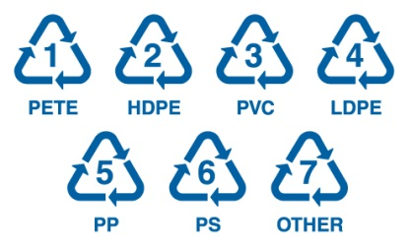
Plastic #1: Polyethylene Terephalate (PET, PETE)
- Common uses: soft drink bottles, cooking oil bottles, peanut butter jars, etc. #1 PETE is the most widely recycled grade of plastic. Please remember to rinse and remove all caps.

Plastic #2: High Density Polyethylene (HDPE)
- Common uses: milk jugs, detergent bottles, windshield washer jugs, etc. Please remember to rinse and remove all caps.

Plastic #3: Polyvinyl Chloride (PVC)
- Common uses: hard plastic water bottles, salad dressing and liquid detergent containers. Remember to rinse and removed all caps. Please also note that plastic pipes, outdoor furniture, and other items may be PVC but are not acceptable in a single stream program.

Plastic #4: Low Density Polyethylene (LDPE)
- Common uses: food containers, dry cleaning bags, grocery bags, trash can liners, etc. Please remember to place inside another bag and tie shut. Do not recycle bags that are soiled or food contaminated.

Plastic #5: Polypropylene (PP)
- Common uses: containers for yogurt, margarine and takeout meals; ketchup bottles, syrup bottles, etc. Please remember to rinse and remove all caps.

Plastic #6: Polystyrene (PS)
- Common uses: clamshell takeout containers, yogurt containers, and margarine containers. Remember to rinse before recycling. Please note that although Styrofoam is technically a #6 plastic, it is not accepted in a single stream program.

Plastic #7: Other
- Common uses: 5 gallon water jugs, some citrus juice and condiment bottles, etc. Please remember to rinse and remove all caps.

General Information
- Please do not recycle: any items soiled or contaminated by food; household garbage or organic waste (ie: food scraps); disposable diapers; medical waste; hazardous chemical containers (ie: motor oil containers); auto parts; batteries; scrap metals; propane tanks, gas cans, or other fuel containers; construction or demolition material; cookware; wire or plastic clothes hangers; plastic containers without #1-#7 symbol (such as clam-shell containers); plastic toys or Tupperware; plastic pipe; outdoor lawn furniture.

